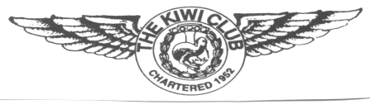
THE KIWI CLUB
CHAPTER CHARITABLE ACTIVITY REPORT FORM

Due Date: December 30 of the year preceding the National Convention. The Kiwi Club's national awards are presented at each convention. In order for chapters to be considered, the Chapter Charitable Activity Report form must be completed and received by the National President by the due date shown above. These awards are based on all your Chapter charitable activities during this term and will be evaluated by the National Executive Board. Include hands-on activities as well as monetary donations. This is for chapter charitable activities only, individual activities should not be included.

Chapter Name: ___________________________________________No. of Members: __________

Chapter President: ______________________________________________________________________
First Maiden Last

Report Submitted by:________________________________________________________________________
First Maiden Last

Chapter Office Held: ______________ Phone): ______________ Email: _____________________________

Charity Name(s) and Years Served: ____________________________________________________________
___________________________________________________________________________________________
___________________________________________________________________________________________
Amount Donated this term: $____________If known, grand total donated: $________________

Please describe the charitable activities by your chapter. Use the back of the form if necessary.
_________________________________________________________________________________
_________________________________________________________________________________
_________________________________________________________________________________
_________________________________________________________________________________
_________________________________________________________________________________
_________________________________________________________________________________
Return the form to the National President

Revised 1/22: GMP

