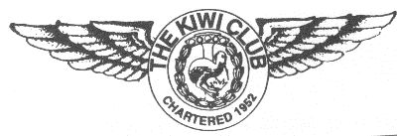
THE KIWI CLUB
POLLY TOLL GOODMAN AWARD Nomination Form

This form is to be used when nominating a Kiwi for the Polly Toll Goodman Award.
All nominees must be current members of The Kiwi Club in order to be considered. Guidelines are available on the web site or from the National Board for use in making this nomination. All requested information must be given in order for the nominee to be considered. If needed, please use the back of the form or attach additional pages.
Please type or print legibly; when the form has been completed, please send to the
NATIONAL PRESIDENT.

Name of Nominee: ___________________________________________________________________
First Maiden Last

Nominee’s Chapter:______________________________________________________ Date:______________

Your Name: _______________________________________________________________________________ First Maiden Last

Chapter or MAL:____________________________________________________________________________

Your Address: ______________________________________________________________________________

Telephone:_________________________________ E-mail:_________________________________________

Please use the following qualities and attributes as guidelines when making your nomination. Describe why you feel this member is deserving of this award.
- Mentor
- Organizer
- Leader
- Advisor
- Kiwi Spirit
- Contributions and service to The Kiwi Club on both a chapter and national level.

Please type or print legibly:

Revised 1/22: GMP

